ANSWER 1
- List any 4 benefits of the First Mile connectivity project of CIL to mining logistics
  - Mitigation of Air Pollution,
  - Eliminate Under loading Overloading,
  - Reduction in loading time of rakes from three hours to within one hour,
  - Reduction in rake turn around time ie. load transported/rake/day will increase,
  - Reduction in Road Accident.
  - First Mile Connectivity will promote ease of living in coal mine areas by reducing traffic congestion, road accidents and adverse impact on environment
- Name any 4 modes of coal transport from mines and rank them in order of magnitude of material transported
  - Rail
  - Trucks
  - Conveyor
  - MGR
- List any 4 measures taken by the Indian railways to increase coal transportation
  - Monitoring the entire cycle
  - significant upgrade of track infrastructure near mines that will be focused on coal bearing regions
  - deploys additional rakes to transport coal to power plants,
  - Indian Railways has prioritised the movement of coal to long distance power houses as well which is reflected in the fact that the average lead of coal trains has increased by 7 per cent
ANSWER 2
    - i. y has the most negative value ( -12) in the objective function. The chosen row is row 3 (20/4=5) smallest positive amongst others. Hence pivot element is 4
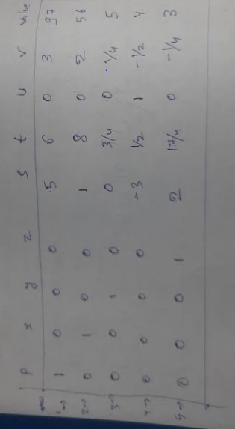
b. the above tableau solves the problem since there is no negative value in the objective function.
c. P max is 97 and x=56, y=5, z= 3
d. s=0, t=0, u=4, v=0
Three s,t, and v have no slack and u has some slack ( in the 3rd constraint)

ANSWER 3

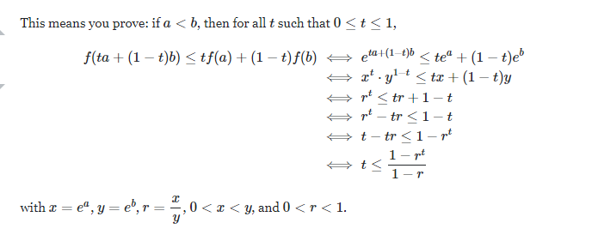

ANSWER 4
Mine 1 (40 cobalt, 15 nickel),
Mine 2 (20 Cobalt, 30 Nickel)
- 40x + 20y >= 100
- 15x + 30y >= 150
Minimize 3000x+ 9000 y

Drawing it graphically the optimal point is (5,5/2)=37.5 k
Other corner points are (5,5) and (0,5)

ANSWER 5
8*900+12*300+12*700+11*200+ 10*1000
Vogels Approximation: Rs 31400

Degeneracy check= m+n-1= 5 which is the no allocated cells
Solution is not degenerate
ii. V3=0, v2=-1, u3=11, u2=12, v1=0, u1=8
iii. d12=3; d13=4; d22=2; d31=3
- All dij’s are +ve hence this solution is optimal hence final total cost after MODI method is 31400

ANSWER 6
